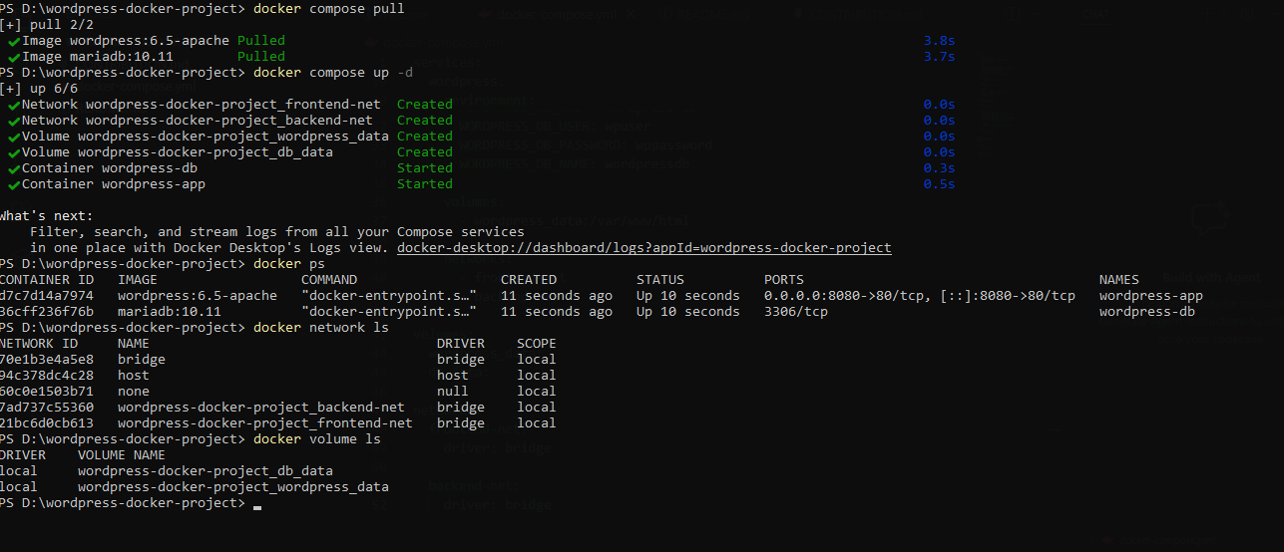

Site Title | : Cloud Computing Project

Username | : admin

Password | : admin123

Email | : putragabrielle19@gmail.com

